*For Question 1 and Question 2, I use SPSS to solve.

*For Question 3, Question 4, and Question 5, I use R Script file to solve.

Question 1

1. Let X be number of incoming service request through text messages in the sample of 10.

$$X \sim B\left(10,0.25\right)$$

$$P\left(x\right)=\left(\begin{matrix}10 \\ x\end{matrix}\right){\left(0.25\right)}^{x}{\left(0.75\right)}^{10-x}$$

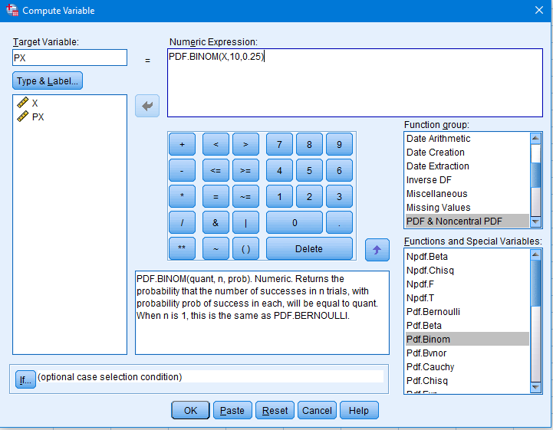

Diagram 1.1 Numeric Expression of P(x) in Binomial Distribution.

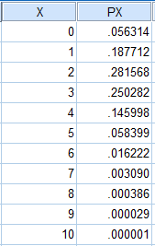

Diagram 1.2 Table of *x* value and Probability

1. Probability that the sample contains at most 5 service requests through voice calls is equal to Probability that at least 5 service requests through text messages.

From (a)

$$P\left(X≥5\right)=P\left(5\right)+P\left(6\right)+P\left(7\right)+P\left(8\right)+P\left(9\right)+P\left(10\right)$$

$$=0.058399+0.016222+0.003090+0.000386+0.000029+0.000001$$

$$=0.078127$$

Question 2

1. To find reasonable range, Assume Z = 3 which has Confidence Interval of almost 99.7% from Empirical Rule. ($μ±3σ)$

Let X be the life span of calculators

$$X\sim N({65,10}^{2})$$

$$Confidence Interval=65±3\left(10\right)$$

$$=\left[35,95\right]$$

$$=\left[30,100\right]$$

Expand the range by 5 for more detail that more than 99.7% of Confidence Interval.

$$Let the interval, i=5$$

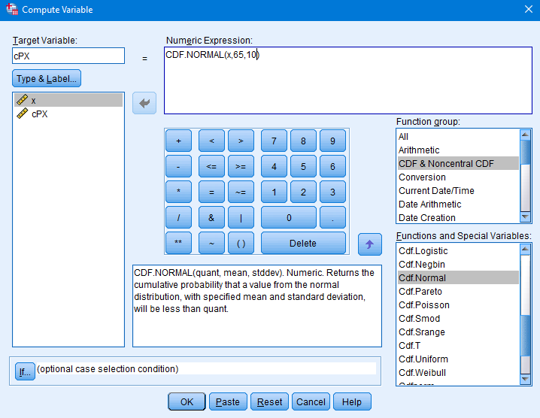

Diagram 2.1 Numeric Expression of CP(x) in Cumulative Normal Distribution.

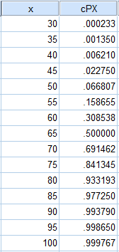

Diagram 2.2 Table of *x* value and Cumulative Probability ($P(X≤x)$)

1. Probability that a calculator of the brand will have life span at least 6 years is equal to Probability that a calculator of the brand will have life span at least 72 months

$$P\left(X≥72\right)=1-P(X<72)$$

We insert one more row for $x=72$

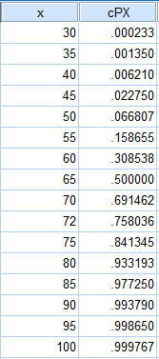

Diagram 2.3 Modified Table of *x* value and Cumulative Probability with new X

From Table

$$P\left(X≥72\right)=1-0.758036$$

$$=0.241964$$

1. The minimum life span of the 20% most durable calculators of this brand.

So, We Add new columns for Inverse Normal Distribution with y as life span of calculator. $Y\sim N({65,10}^{2})$

$$P\left(Y≥y\right)=0.2$$

$$P\left(Y<y\right)=0.8$$

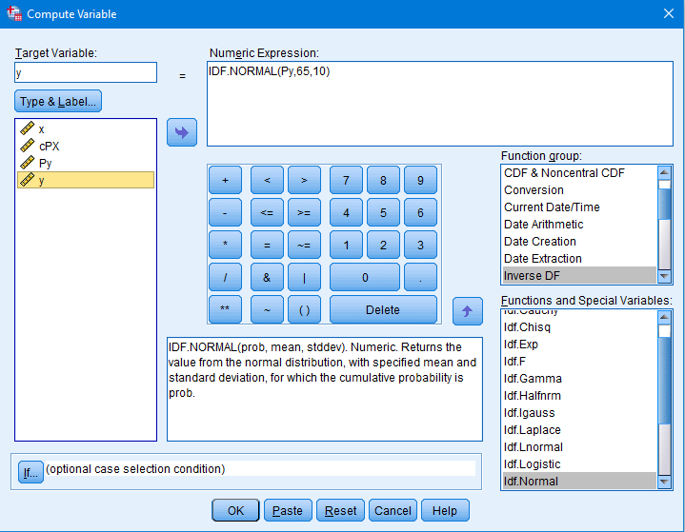

Diagram 2.4 Numeric Expression of y in Inverse Normal Distribution.

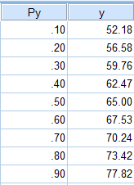

Diagram 2.5 Table of Cumulative Probability ($P(Y≤y)$) and *y* value

From Table,

Since the table is show cumulative Probability $P(Y<y)$

$$P\left(Y<73.42\right)=0.8$$

Then, $P\left(Y≥73.42\right)=0.2$

$Since Y ∈Z$, Then $Y=74$

Therefore, the minimum life span of the 20% most durable calculators of this brand is 74 months

Question 3

$H_{0}:$ There is no association between percentage of customers who think the food and service are excellent and restaurant in different area of a city.

$H_{1}:$ There is an association between percentage of customers who think the food and service are excellent and restaurant in different area of a city.

|  |  |  |  |
| --- | --- | --- | --- |
| Restaurant in Area | Number of customers who think the food and services | | Total |
| Poor | Excellent |
| A | 82 | 118 | 200 |
| B | 90 | 160 | 250 |
| Total | 172 | 278 | 450 |

$$Critical Value : χ_{0.1;(2-1)(2-1)}^{2}=2.705$$

$$Rejection Region : χ^{2}>2.705$$

Or

$$Rejection Region : p-value<0.1$$

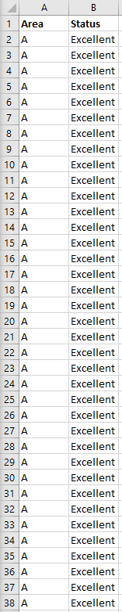

Diagram 3.1 Table of Area and Services Status created in Excel File

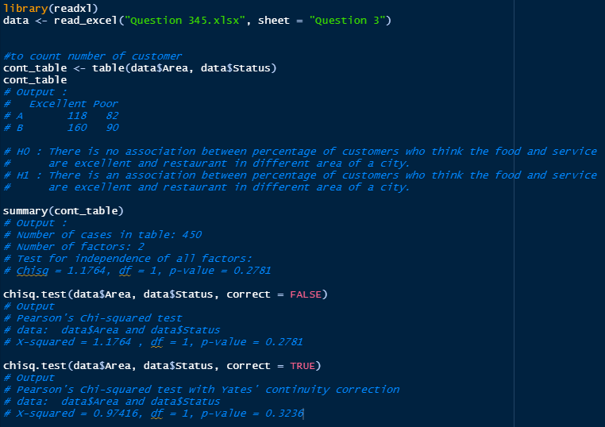

Diagram 3.2 Source code and Output of R programming to perform Chi-Square Test

From the Diagram 3.2, Since the degree of freedom $df=1$. I will use Yates’ continuity correction in the function *chisq.text()* as additional result.

Conclusion:

Since $p-value= 0.2781>0.1 or p-value=0.3236>0.1$ (Yates’ Continuity Correction), We failed to reject $H_{0}$ and conclude that there is no association between percentage of customers who think the food and service are excellent and restaurant in different area of a city.

Question 4

$H_{0}:σ_{A}^{2}=σ_{B}^{2}$, Time taken for both machines to assemble the products have the same variance

$H_{0}:σ_{A}^{2}≠σ_{B}^{2}$, Time taken for both machines to assemble the products **does not** have the same variance

$$Rejection Region :p-value<0.05$$

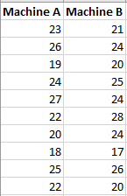

Diagram 4.1 Table of Time Taken (in Minutes) to assemble a fixed number of products using Machine A and Machine B created in Excel File

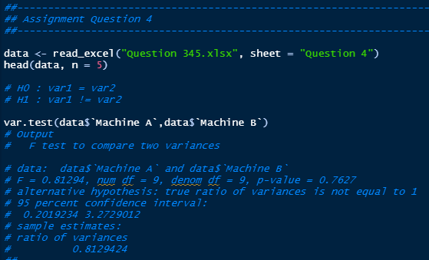

Diagram 4.2 Source code and Output of R programming to perform variance Test

From the Diagram 4.2,

Since $p-value=0.7627>0.05$, we failed to reject $H_{0}$ and conclude that the time taken for both machines to assemble the products have the same variance

$H_{0}:μ_{A}≤μ_{B}$, Mean time taken to assemble the product by using Machine A is shorter than mean time taken to assemble the product by using Machine B

$H_{0}:μ_{A}>μ_{B}$, Mean time taken to assemble the product by using Machine A is **not** shorter than mean time taken to assemble the product by using Machine B.

$$Rejection Region :p-value<0.05$$

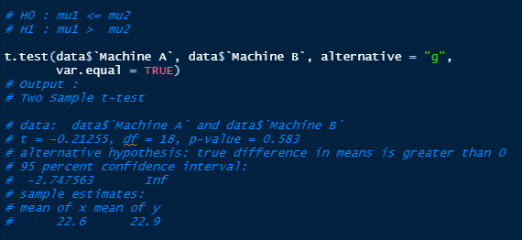

Diagram 4.3 Source code and Output of R programming to perform T Test

From the Diagram 4.3,

Since $p-value=0.583>0.05$, we failed to reject $H_{0}$ and conclude that mean time taken to assemble the product by using Machine A is shorter than mean time taken to assemble the product by using Machine B. Therefore, Machine A is recommended to choose to assembly the product in shorter time.

Question 5

$H_{0}$: There is no association between the number of cars at different seasons and zones.

$H_{1}$: There is an association between the number of cars at different seasons and zones.

$$Rejection Region :p-value<0.05$$

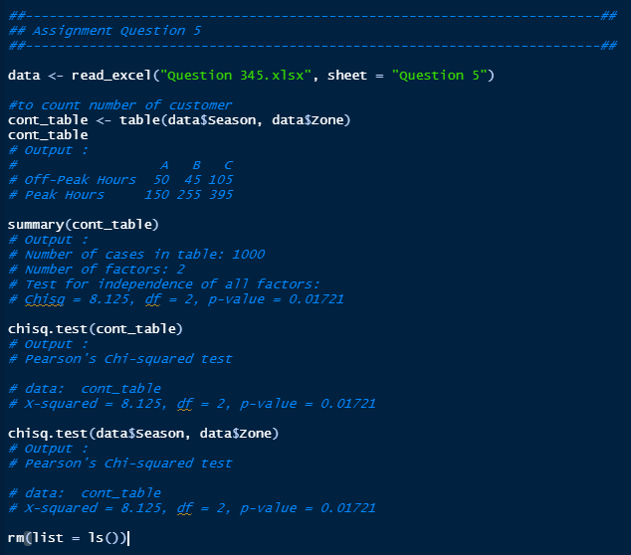

Diagram 5.1 Source code and Output of R programming to perform Chi Square Test

From the Diagram 5.1,

Since $p-value=0.01721<0.05$, we reject $H_{0}$ and conclude that there is an association between the number of cars at different seasons and zones.